**Online Learning Management System**

1. Creating the tables.

**Instructor Table**

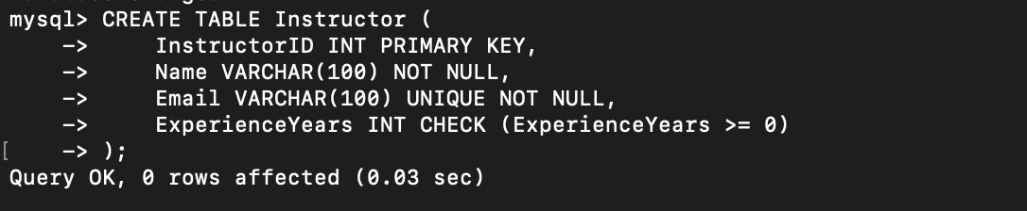

**Course Table**

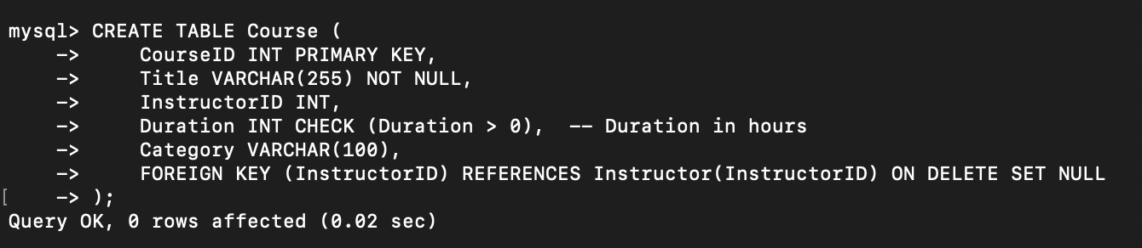

**Student Table**

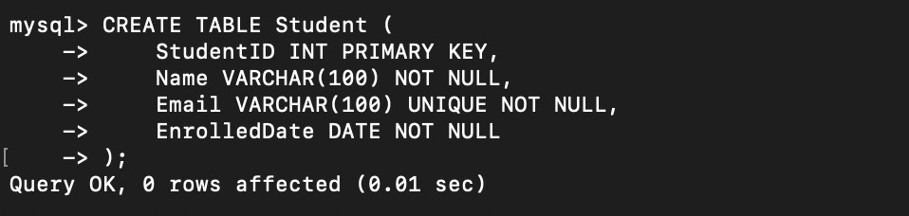

**Enrollment Table (Bridge Table)**

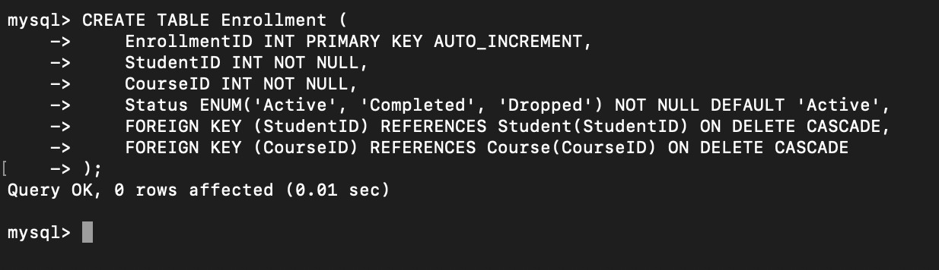

1. Inserting sample data.

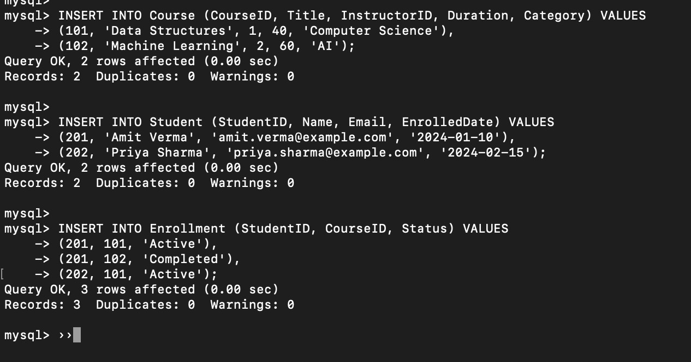

1. Retrieve courses with the highest enrollment.

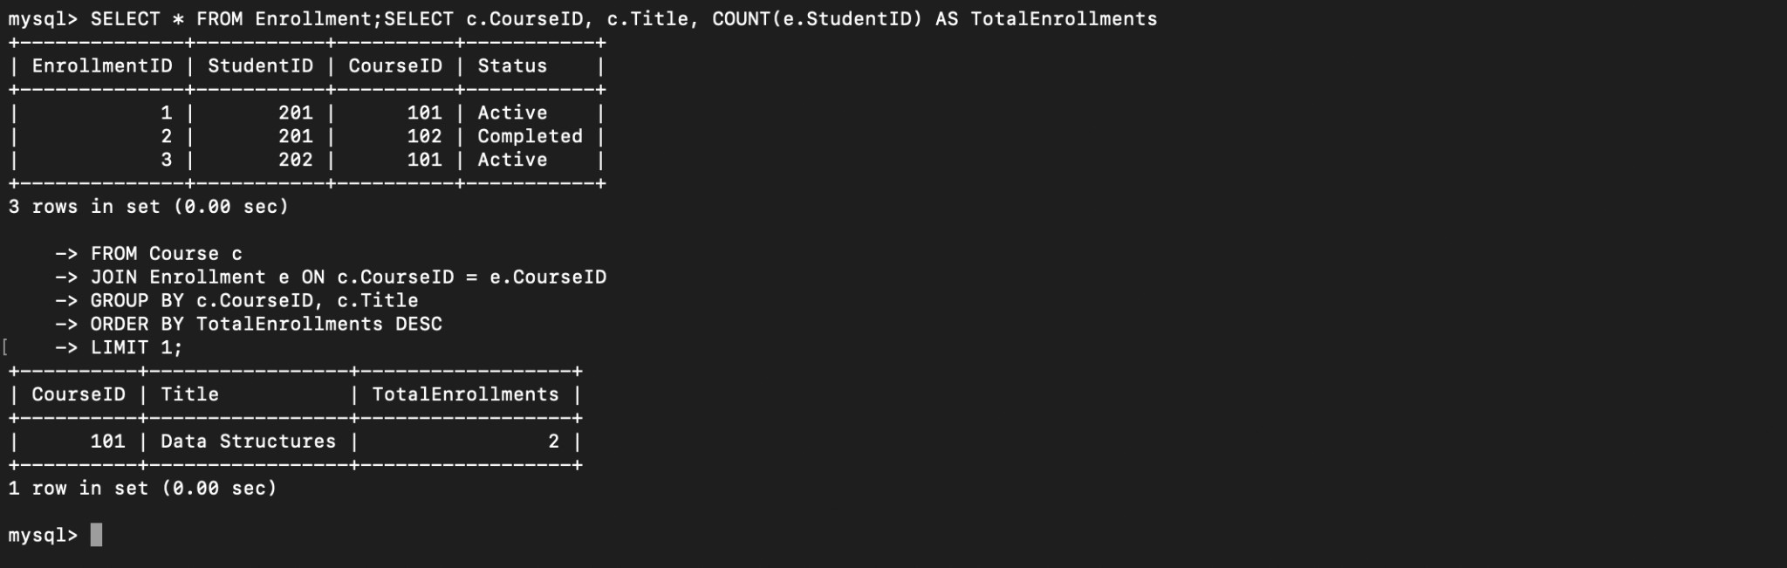

1. Find instructors who have the most students.

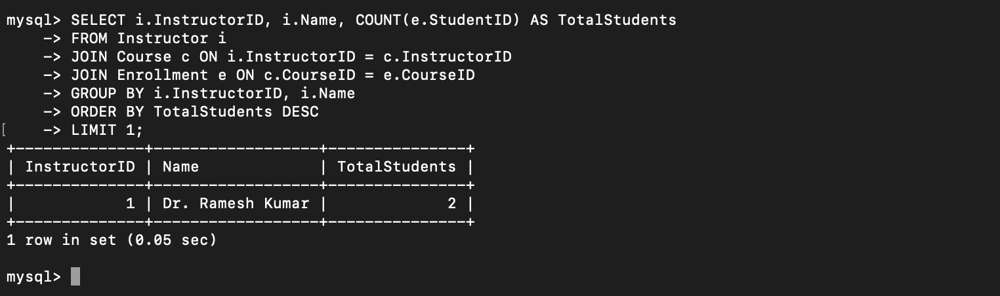

1. Display students enrolled in multiple courses.

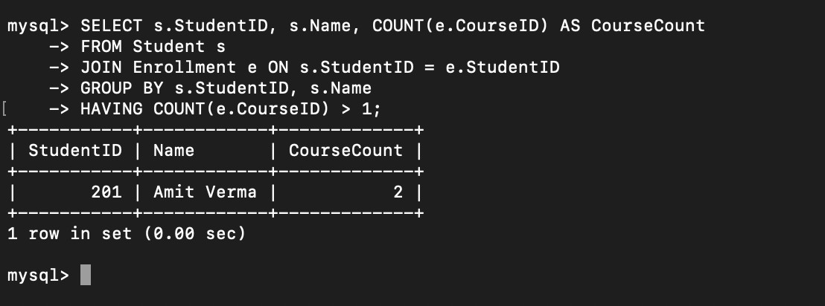

1. Retrieve courses that have no enrollments.

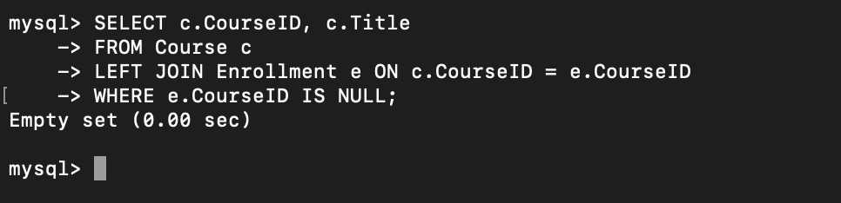

1. Find students who joined within the last 3 months.

